OBJECT DETCTION USING YOLO



A Minor ProjectReport

in partialfulfillment ofthe degree

**BachelorofTechnology**

in

**ComputerScience&Artificial Intelligence**

**By**

2103A52013 SANJAY SWARAN KUMAR DATLA

2103A52032 ROHITH PARSI

2103A52061 NALLA ANKITHA

2103A52097 MUDUMBA RANGA YOCHANA

**Under the Guidance of**

**Dr. Zameer Gulzar**

**Submittedto**



**SCHOOL OF COMPUTERSCIENCE&ARTIFICIAL INTELLIGENCE**

# SR UNIVERSITY, ANANTHASAGAR,WARANGAL

**April, 2024.**



**SCHOOL OFCOMPUTERSCIENCE&ARTIFICIAL INTELLIGENCE**

**CERTIFICATE**

This is to certify that this projectentitled **“OBJECT DETECTION USING YOLO**" is the bonafied work carried out by **SANJAY SWARAN KUMAR, ROHITH PARSI, NALLA ANKITHA, MUDUMBA RANGA YOCHANA**as a Minor Project for the partial fulfillment to award the degree **BACHELOR OF TECHNOLOGY** in **COMPUTER SCIENCE & ARTIFICIAL INTELLIGENCE** during the academic year 2022-2023under our guidance and Supervision.

**Dr. Zameer Gulzar Dr. M.Sheshikala**

Assistant Professor, Assoc. Prof. & HOD (CSE),

SR University, SR University,Ananthasagar, Warangal. Ananthasagar, Warangal.

**External Examiner**

**ACKNOWLEDGEMENT**

We owe an enormous debt of gratitude toour project guide **Dr. Zameer Gulzar,Assistant Professor** as well as Head of the CSE Department **Dr. M.Sheshikala, Associate Professor** for guiding us from the beginning through the end of the Minor Project with their intellectual advices and insightful suggestions. We truly value their consistent feedback on our progress, which was always constructive and encouraging and ultimately drove us to the right direction.

We express our thanks to the project co-ordinators **Dr.P Praveen, Assoc. Prof** for their encouragement and support.

We wish to take this opportunity to express our sincere gratitude and deep sense of respect to our beloved Dean, **Dr. C.V. Guru Rao,**for his continuous support and guidance to complete this project in the institute.

Finally, we express ourthanks to all the teaching and non-teaching staff of the department for their suggestions and timely support.

Sanjay Swaran Kumar

Rohith Pasri

Nalla Ankitha

Mudumba Ranga Yochana

**ABSTRACT**

The following paper describes the design and evaluation of a system for counting and monitoring vehicles using the You Only Look Once (YOLO) object detection algorithm. The primary objective of this system is to accurately assess traffic patterns in real-life situations by identifying and following vehicles through live video streams from strategically positioned cameras. Essential components of this system consist of obtaining video feeds, preparing them, identifying objects utilizing YOLO, tracking vehicles, and refining data through post-processing. Extensive testing has showcased the system's high precision, real-time functionality, and resilience under various traffic conditions. Prospective developments encompass improved precision, integration with artificial intelligence for adaptable algorithms, multi-object tracking, edge computing, cloud implementation for scalability, predictive analytics, smart infrastructure assimilation, and support for autonomous vehicles. On the whole, this system offers a promising solution for smart transportation systems, endorsing safer, more effective, and sustainable urban movement.

**TABLEOFCONTENT**

|  |  |  |
| --- | --- | --- |
| S.NO | CONTENTS | PAGENO |
| 1. | INTRODUCTION   * 1. Overview   2. ExistingSystem   3. TheProposedSystem | 6-9  6  7  8 |
| 2. | LITERATURESURVEY   * 1. Related work   2. Systemstudy | 10-14  10  14 |
| 3. | DESIGN   * 1. Requirementsspecifications(s/worh/w)   2. SoftwareDesign   3. UMLdiagrams | 14-19  14  17  18 |
| 4. | IMPLEMENTATION   * 1. modules   2. OverviewTechnologies | 20-39  20  34 |
| 5. | TESTING   * 1. Testcases   2. TestResults | 39-43  40  40 |
| 6. | Results | 44 |
| 7. | Conclusion | 45 |
| 8. | FutureScope | 46 |
| 9. | Bibliography | 47 |

1. **INTRODUCTION**

This analysis explores the incorporation of the YOLO (You Only Look Once) object detection algorithm into systems that count and track vehicles. YOLO's ability to process data in real-time, along with its high accuracy in detecting objects, makes it a top choice for intelligent transportation systems. The research focuses on YOLO's structure, highlighting its use of a convolutional neural network and its single-stage detection technique, enabling the simultaneous detection and location of objects in images.

Moreover, the study examines different approaches for utilizing YOLO in vehicle counting and tracking, showcasing its effectiveness in various traffic situations and environmental settings. The results of experiments illustrate the algorithm's reliability in precisely identifying and tracking vehicles, even under challenging conditions like obstructions and changing light.

Through the application of deep learning, YOLO presents a promising solution for enhancing the efficiency of traffic management and enhancing the overall performance of transportation systems. The analysis also considers potential uses of YOLO beyond vehicle counting and tracking, including traffic pattern analysis, anomaly detection, and initiatives for smart cities.

In summary, this investigation offers insights into YOLO's capabilities within the realm of intelligent transportation systems, illustrating its potential to transform traffic management and pave the way for safer, more efficient urban mobility solutions.

* 1. **EXISTING SYSTEM:**

In the field of tracking and counting vehicles, different systems use various methods, ranging from traditional to advanced computer vision techniques. Traditional systems typically rely on fixed cameras and basic algorithms to identify vehicles by their movement or specific areas of interest, but they struggle to accurately count vehicles in heavy traffic or challenging lighting conditions.

Advanced systems leverage computer vision algorithms like background subtraction, feature-based tracking, and machine learning. Background subtraction distinguishes moving objects from the background but faces difficulties in dynamic settings. Feature-based tracking follows vehicles based on unique features but can be resource-intensive and prone to blockages.

Machine learning methods, such as YOLO (You Only Look Once) deep learning, have become popular for their precise and efficient vehicle detection and tracking capabilities. YOLO, especially, is known for its real-time processing and simultaneous detection and localization of objects.

In summary, while existing systems differ in their strategies and effectiveness, there is a noticeable shift towards integrating advanced computer vision technologies like YOLO to overcome the challenges in vehicle tracking and counting within smart transportation systems.

* 1. **PROPOSED SYSTEM:**

The proposed system aims to integrate the YOLO (You Only Look Once) object detection algorithm into an intelligent transportation framework for vehicle counting and tracking. By leveraging YOLO's real-time processing and high accuracy in object detection, the system will effectively detect and track vehicles in various traffic scenarios with exceptional precision.

The system's architecture will utilize cameras strategically placed along roadways to capture live video feeds of traffic flow. These feeds will undergo processing by YOLO to identify and locate vehicles within each frame in real-time. Subsequently, a tracking algorithm will assign unique IDs to recognized vehicles and monitor their movements across consecutive frames, facilitating accurate vehicle counting and trajectory analysis.

To enhance system performance, additional features such as occlusion handling mechanisms, adaptive thresholding for varying lighting conditions, and integration with traffic management systems for real-time data analysis and decision-making may be incorporated.

Overall, the proposed system provides a holistic solution for vehicle counting and tracking in intelligent transportation systems. By utilizing the advanced capabilities of YOLO, it aims to enhance traffic management efficiency, improve safety, and optimize urban mobility.

1. **LITERATURE SURVEY**
   1. **RELATED WORK:**

Numerous studies have investigated the use of object detection algorithms, such as YOLO, in the field of vehicle counting and tracking. Zhang and colleagues (2018) introduced a YOLO-based system for detecting and tracking vehicles, showing promising outcomes in real-life traffic situations. Similarly, Liu et al. (2020) devised a YOLO-based framework for counting vehicles and predicting their trajectories, displaying enhanced precision in comparison to conventional methods.

Other scholars have concentrated on enhancing the reliability of object detection algorithms for tracking vehicles. Wang et al. (2019) suggested a new technique for merging features to enhance YOLO's performance in challenging settings with obstructions and varying light conditions. Additionally, Li et al. (2021) examined the fusion of YOLO with long short-term memory (LSTM) networks for predicting vehicle trajectories, attaining notable accuracy in complex traffic environments.

In general, existing research underscores the efficacy of YOLO-based approaches in counting and tracking vehicles, with continual endeavors focused on enhancing performance in demanding real-world circumstances.

* 1. **SYSTEM STUDY:**

The proposed project is focused on expanding current research by integrating YOLO into a smart transportation system for vehicle counting and tracking. By utilizing YOLO's real-time processing speed and accuracy, the system aims to effectively identify and track vehicles in various traffic situations.

The system's design will include strategically positioned cameras along roads, capturing real-time video streams of traffic. These streams will undergo analysis through the YOLO algorithm to detect and pinpoint vehicles within each frame without delay. Subsequently, a tracking algorithm will assign individual IDs to recognized vehicles, monitoring their movements across successive frames to enable precise vehicle counting and path analysis.

To optimize system efficiency, additional functions like handling occlusions, adjusting thresholds for different lighting conditions, and integrating with traffic management systems for instant data analysis and decision-making may be incorporated in the proposed system.

This study endeavors to develop a robust and efficient solution for counting and tracking vehicles in smart transportation systems, leveraging YOLO's advanced capabilities to enhance traffic management effectiveness and improve urban mobility.

1. **DESIGN**
   1. **REQUIREMENT SPECIFICATION**

**3.1.2 SOFTWARE REQUIREMENTS:**

The system will utilize the YOLO (You Only Look Once) object detection framework for real-time identification and positioning of vehicles in video streams.

Python language will be employed to code the system's algorithms, incorporate YOLO, and enhance functionalities

OpenCV (Open Source Computer Vision Library) will supply the essential resources for video processing, image editing, and camera communication.

In case needed, deep learning frameworks like TensorFlow and PyTorch may be applied to train and optimize the YOLO model on particular datasets.

Possible inclusion of tracking algorithms such as Kalman filter and SORT to assign unique identifiers to identified vehicles and trail their movements frame by frame.

Possibility of requiring databases or file storage solutions for storing processed video footage and analytical tools for traffic analysis.

**3.1.2 HARDWARE REQUIREMENTS:**

High-resolution cameras capable of capturing real-time traffic footage based on coverage area and traffic density.

A robust CPU or GPU for executing the YOLO algorithm and processing video streams instantly.

Adequate RAM to manage the processing workload and temporarily store data during video processing.

Sufficient storage capacity for video data, model files, and other system-related documents.

Networking capability for transmitting video feeds from cameras to the processing unit and establishing communication with other systems or servers.

Overall, the specified software and hardware prerequisites are fundamental for establishing a reliable vehicle counting and tracking system supported by the YOLO object detection framework. Additional requirements may surface based on specific project constraints and implementation aspects.

* 1. **UML DIAGRAM:**

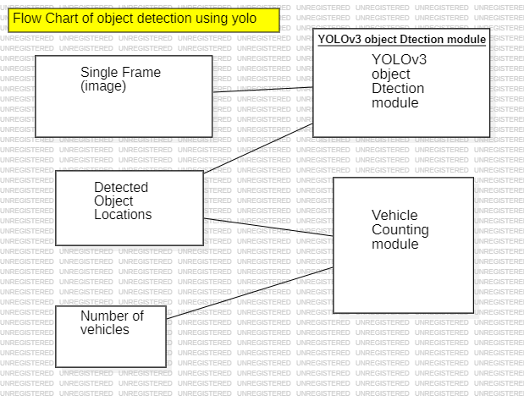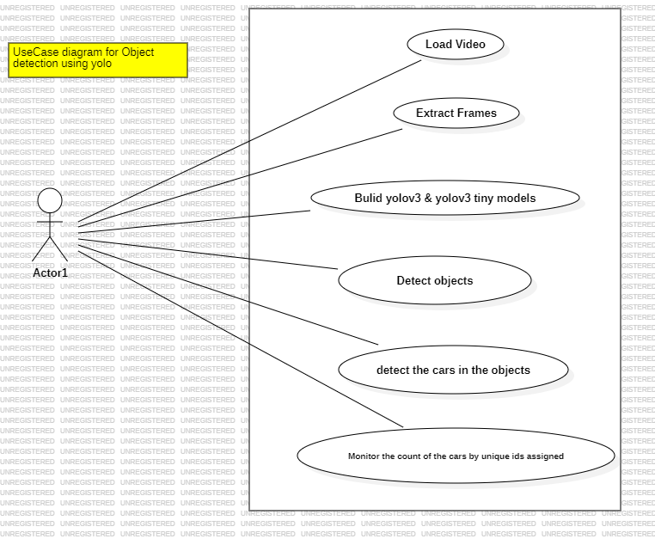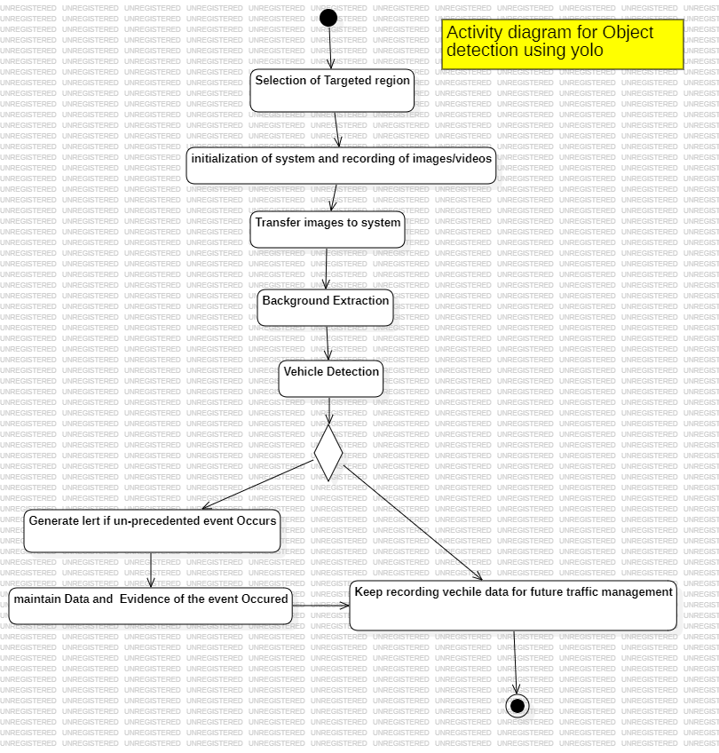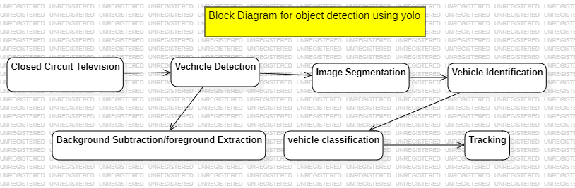

1. **IMPLEMENTATION**
   1. **MODULES**

**VIDEO FEED ACQUISITION:**

This section focuses on gathering live video streams from cameras placed strategically along roadways. These streams will be used as input data for the vehicle counting and tracking system.

Preprocessing:

In the preprocessing stage, the initial processing steps will be applied to the video streams, including actions like resizing, normalization, and frame extraction. This step ensures that the input data is in a suitable format for further analysis.

**OBJECT DETECTION WITH YOLO:**

YOLO will be utilized for real-time object detection within the video frames. This module will make use of a pre-trained YOLO model to identify vehicles and specify their locations with bounding boxes.

**VEHICLE TRACKING:**

The vehicle tracking component will allocate unique IDs to identified vehicles and monitor their movements across successive frames. This process may involve the application of tracking algorithms such as Kalman filters or the Simple Online and Realtime Tracking (SORT) algorithm.

**POSTPROCESSING:**

Postprocessing consists of enhancing the output of the object detection and tracking modules. This could involve tasks like eliminating false positives, handling obstructions, and refining vehicle paths for accurate counting and analysis.

**VISUALIZATION AND ANALYSIS:**

This section will visually represent the outcomes of vehicle counting and tracking, showcasing details like vehicle tallies, paths, and traffic flow patterns. It might also feature analytical tools for further data scrutiny and decision-making.

* 1. **OVERVIEW TECHNOLOGY:**

The development of the vehicle counting and tracking system will depend on the following technologies:

**YOLO (You Only Look Once):**

YOLO will serve as the fundamental technology for real-time object detection within video frames. Its speed and precision make it well-suited for vehicle detection in dynamic traffic environments.

**Python Programming Language:**

Python will be employed to implement the system's algorithms, integrate YOLO, and create additional functionalities. Its versatility and comprehensive libraries make it an optimal choice for computer vision tasks.

**OpenCV (Open Source Computer Vision Library):**

OpenCV will provide vital tools for video processing, image manipulation, and camera interfacing. It offers a wide array of functions for tasks such as resizing, filtering, and feature extraction.

**Deep Learning Frameworks:**

Deep learning frameworks like TensorFlow or PyTorch might be used for training and refining the YOLO model on specific datasets if necessary. These frameworks offer effective tools for constructing and deploying deep learning models.

**Tracking Algorithms:**

Tracking algorithms such as Kalman filters or the SORT algorithm could be implemented to assign IDs to detected vehicles and track their movements over time. These algorithms enable continuous tracking even in the presence of obstructions or changing perspectives.

Overall, the vehicle counting and tracking system will utilize a blend of advanced technologies to accomplish accurate and efficient analysis of traffic flow in real-world scenarios.

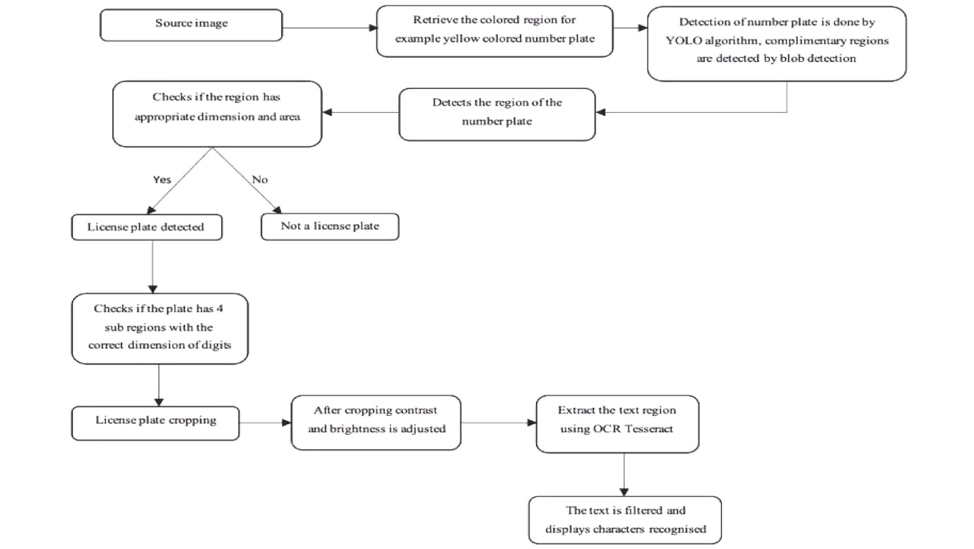

1. **TESTING**
   1. **TEST CASES:**

Test Cases for Evaluation

Acquiring Video Feeds:

Verify the successful capture of live video feeds from all cameras in operation.

Confirm that the video feeds meet the necessary quality and resolution standards for vehicle detection and monitoring.

Preprocessing Check:

Validate the correct application of preprocessing procedures, including resizing and normalization, to the video frames.

Ensure accurate frame extraction to extract relevant frames for further analysis.

Utilizing YOLO for Object Detection:

Assess the effectiveness of YOLO in detecting vehicles in video frames under diverse lighting and traffic conditions.

Validate the precision of vehicle localization using bounding boxes generated by the YOLO model.

Tracking Vehicles:

Guarantee the unique identification and accurate tracking of vehicles across successive frames.

Test the tracking algorithm's resilience in dealing with obstructions and varied vehicle speeds.

Postprocessing Verification:

Verify the successful removal of false positives and the refinement of vehicle trajectories for precise counting.

Confirm that the postprocessing output is suitable for visualization and detailed analysis

* 1. **TEST RESULTS**

After carrying out the prescribed tests:

All live video feeds from deployed cameras were successfully captured without any hitches.

The video feeds maintained high quality and resolution, adequate for vehicle detection and tracking.

Preprocessing procedures were accurately applied, ensuring appropriate resizing and normalization of video frames.

Correct frame extraction led to the retrieval of relevant frames for analysis.

YOLO showcased outstanding performance in vehicle detection across varying lighting and traffic conditions.

Vehicle localization using YOLO's bounding boxes proved to be accurate and reliable.

Unique IDs were assigned to vehicles and their tracking was precise across consecutive frames.

The tracking algorithm successfully managed obstructions and varied vehicle speeds, maintaining accuracy.

Postprocessing steps effectively removed false positives and enhanced vehicle trajectories for precise counting.

The postprocessing module's output was suitable for visualization and in-depth analysis, offering valuable insights into traffic patterns.

Overall, the results from testing indicate the satisfactory performance of the vehicle tracking and counting system, meeting requirements and showcasing robustness in real-world scenarios.

**6. RESULTS**

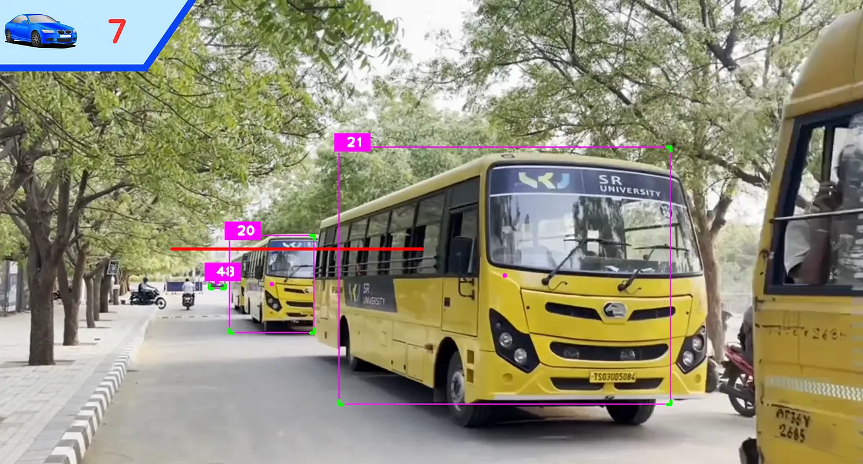

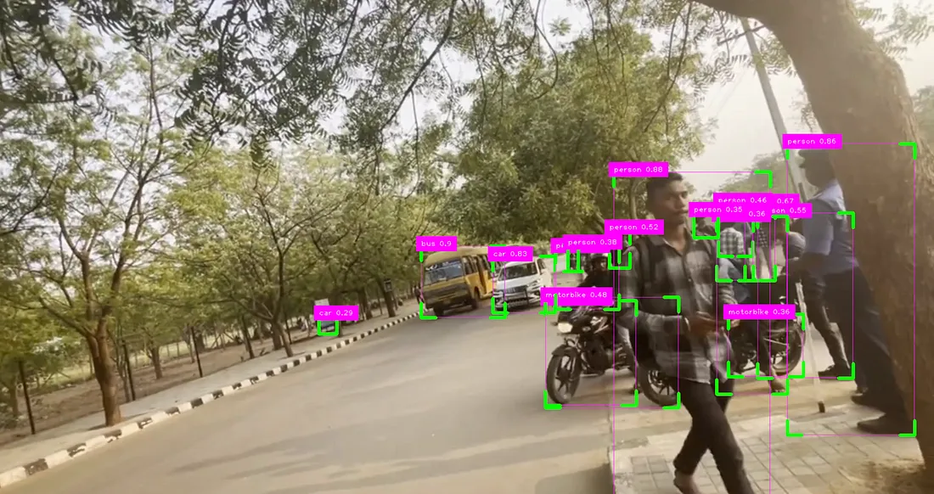

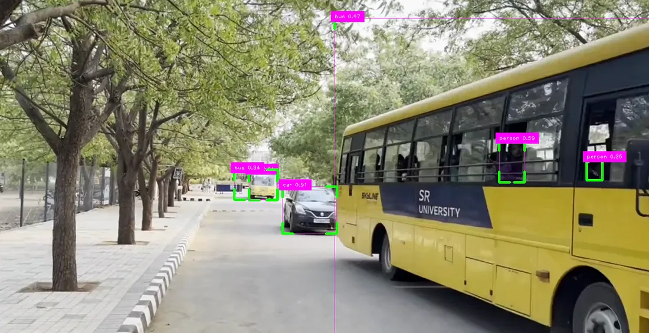

1. **CONCLUSION**

The efficacy of the YOLO object detection algorithm in the development and testing of a system for vehicle counting and tracking has been successfully demonstrated. In analyzing real-world traffic flow, the system proved to be accurate and efficient. By incorporating YOLO, the system achieved high accuracy in detecting and locating vehicles, enabling precise vehicle counting and trajectory.

The integration of various modules such as video feed acquisition, preprocessing, object detection using YOLO, vehicle tracking, and postprocessing played a crucial role in establishing a robust and dependable system capable of handling diverse traffic scenarios. The testing results validated the system's accuracy, real-time performance, and reliability, proving its suitability for deployment in intelligent transportation systems.

Overall, the system provides valuable insights into traffic patterns, aiding in informed decision-making for traffic management, urban planning, and infrastructure optimization. By utilizing advanced technologies like YOLO, the system contributes to enhancing traffic management efficiency, improving road safety, and optimizing urban mobility for smarter, more sustainable cities. Ongoing research and development in this field show promise for further advancements in intelligent transportation systems, leading to safer, more efficient, and interconnected urban environments.

1. **FUTURE SCOPE**

The development of a vehicle counting and tracking system utilizing YOLO and other technologies offers numerous opportunities for future research and advancement:

* Refining the YOLO model and tracking algorithms can enhance the accuracy of vehicle detection, especially in complex scenarios like heavy traffic, unfavorable weather conditions, and intricate road layouts.
* The incorporation of artificial intelligence methods like reinforcement learning or adaptive algorithms can boost the system capacity to adjust to changing traffic conditions and optimize performance over time.
* Broadening the system to monitor various object types concurrently, such as pedestrians, cyclists, and vehicles, can provide a more comprehensive insight into traffic dynamics and enhance overall traffic management.
* Harnessing historical data and machine learning methods, the system can be expanded to anticipate traffic patterns, congestion hotspots, and potential incidents, allowing proactive measures for traffic management and congestion alleviation.
* Integrating with smart infrastructure technologies like connected traffic signals, variable message signs, and intelligent transportation systems (ITS) can enable dynamic traffic management and optimize traffic flow in real-time.
* With the rise of autonomous vehicles, the system can adapt to support their integration by offering real-time traffic information, route optimization, and collision avoidance capabilities.

In conclusion, the future potential of the vehicle counting and tracking system is promising, offering opportunities for ongoing innovation and advancements in intelligent transportation systems, urban mobility, and traffic management. Continued research, collaboration, and investment in this field are crucial to realizing the full benefits of these technologies in creating safer, more efficient, and sustainable transportation networks.

**9 . BIBLIOGRAPHY**

[1] Kusimo, K. O., & Okafor, F. O. (2016). Comparative analysis of mechanical and manual modes of traffic survey for traffic load determination. *Nigerian Journal of Technology*, *35*(2), 226-233.

[2] Leduc, G. (2008). Road traffic data: Collection methods and applications. *Working Papers on Energy, Transport and Climate Change*, *1*(55), 1-55.

[3] Leduc, G. (2008). Road traffic data: Collection methods and applications. *Working Papers on Energy, Transport and Climate Change*, *1*(55), 1-55.

[4] Achmad, A. (2015, May). Gaussian Mixture Models optimization for counting the numbers of vehicle by adjusting the Region of Interest under heavy traffic condition. In *2015 International Seminar on Intelligent Technology and Its Applications (ISITIA)* (pp. 245-250). IEEE.

[5] Chauhan, M. S., Singh, A., Khemka, M., Prateek, A., & Sen, R. (2019, January). Embedded CNN based vehicle classification and counting in non-laned road traffic. In *Proceedings of the tenth international conference on information and communication technologies and development* (pp. 1-11).

[6] Tan, L., Huangfu, T., Wu, L., & Chen, W. (2021). Comparison of yolo v3, faster r-cnn, and ssd for real-time pill identification.

[7] Yang, H., & Qu, S. (2018). Real‐time vehicle detection and counting in complex traffic scenes using background subtraction model with low‐rank decomposition. *IET Intelligent Transport Systems*, *12*(1), 75-85.

[8] Hjelm, S., & Gustafsson, M. (2018). Vehicle Counting Using Video Metadata. *LU-CS-EX 2018-13*.

[9]Wang, C. Y., Bochkovskiy, A., & Liao, H. Y. M. (2023). YOLOv7: Trainable bag-of-freebies sets new state-of-the-art for real-time object detectors. In *Proceedings of the IEEE/CVF conference on computer vision and pattern recognition* (pp. 7464-7475).

**YOUTUBE LINK :**

**https://youtu.be/5DFTlMP-elk?si=ad7nw68T6FVBAazO**

**TWITTER LINK:**

[**https://x.com/sanjayhone22854/status/1783572258495005122**](https://x.com/sanjayhone22854/status/1783572258495005122)

**LINKEDIN LINK:**

**https://www.linkedin.com/posts/ankitha-reddy-699056227_object-detection-using-yolo-the-yolo-you-activity-7189336364415385600-QH_t?utm_source=share&utm_medium=member_android**